**ML and Data Science -Achievement URL Redemption Steps**

1. Open an Incognito window, in a new tab, paste the following Achievement URL and click enter.

https://learn.microsoft.com/en-us/users/me/achievements?redeem=N8G59V&WT.mc_id=ilt_partner_webpage_wwl&ocid=6236893

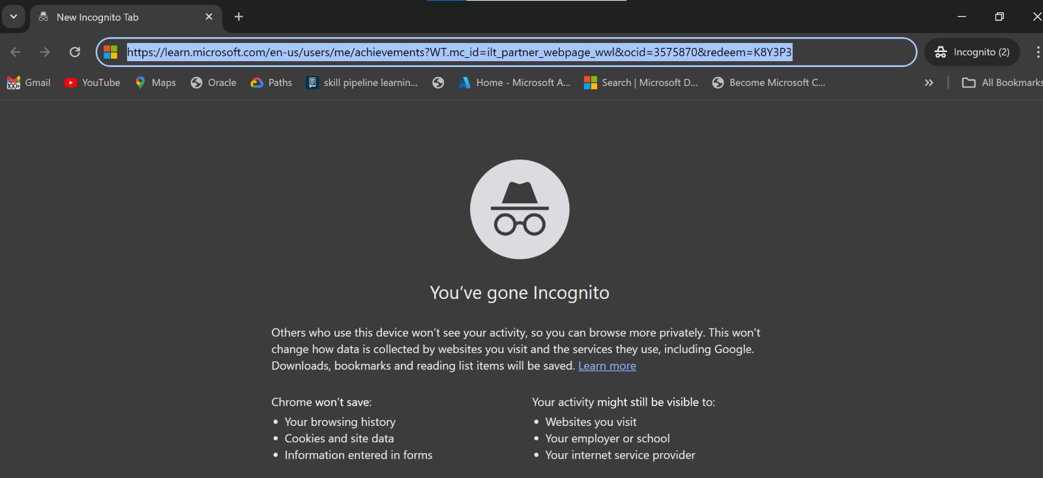

1. You will be asked to Sign in. Please Sign in using your **Personal Microsoft Account. (NOT EY Account)**

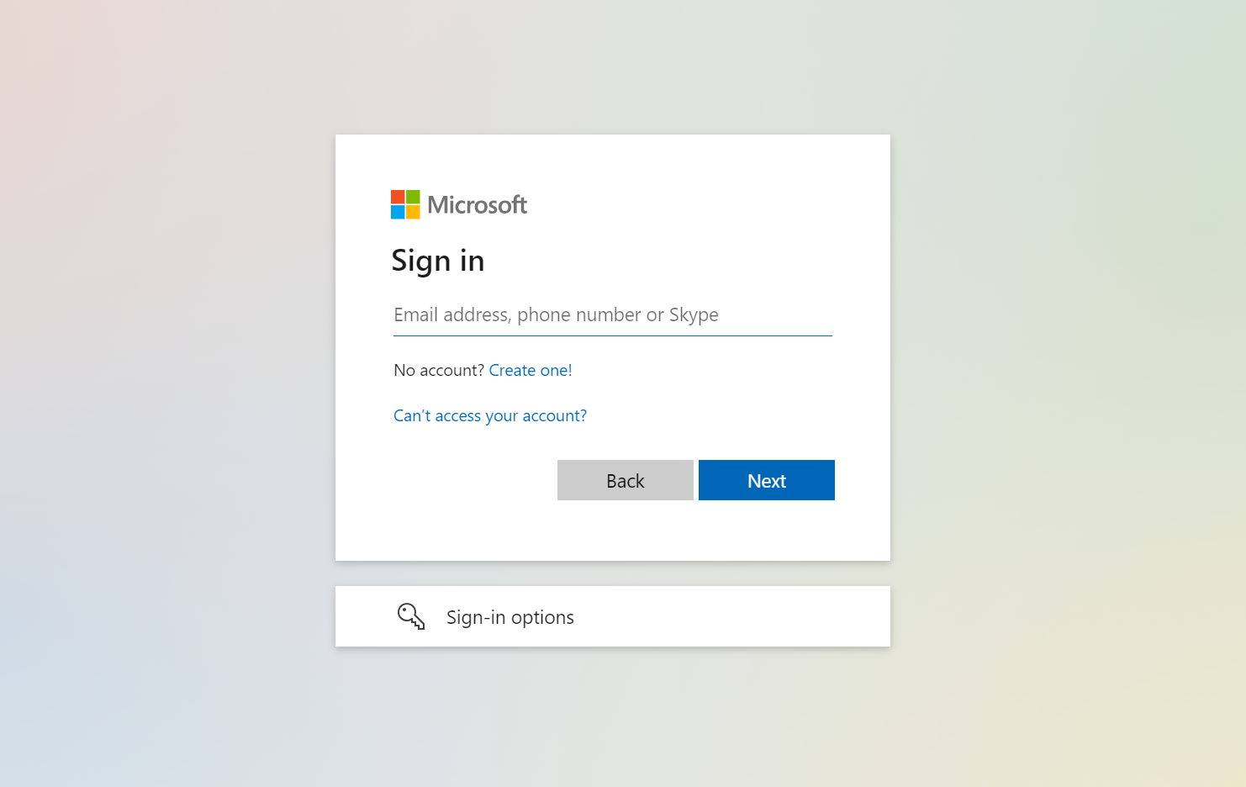

1. After successfully signing in, click on Redeem.

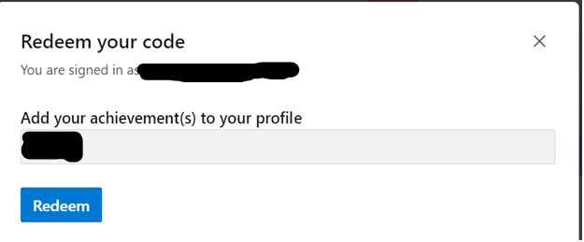

1. Upon successful redemption, you will be able to see the Badges, Modules and Trophies earned.

